INC
The Bellarine Camera Club
ANNUAL
PHOTOGRAPHIC EXHIBITION
On Saturday the 14th and Sunday the 15th of October, 2017 between the hours of 10am to 4pm the Bellarine Camera Club will hold its Annual Photographic Exhibition at the Springdale Neighbourhood Centre, Main Hall situated in High Street Drysdale just opposite the Shopping Centre. An interclub competition will also form part of this display. The theme for this year’s competition is “HISTORY OF BELLARINE” Entry for Club members only.
Images from local photographers will be on display for your viewing pleasure. Meet the photographers and possibly purchase one of their works. (Cash Sales Only)
This club has been together for the past 7 years and is always seeking new members. This exhibition is to show the local and outside public the beauty of photography and how it never ceases to amaze people with images that portray life as it is today and in the past.
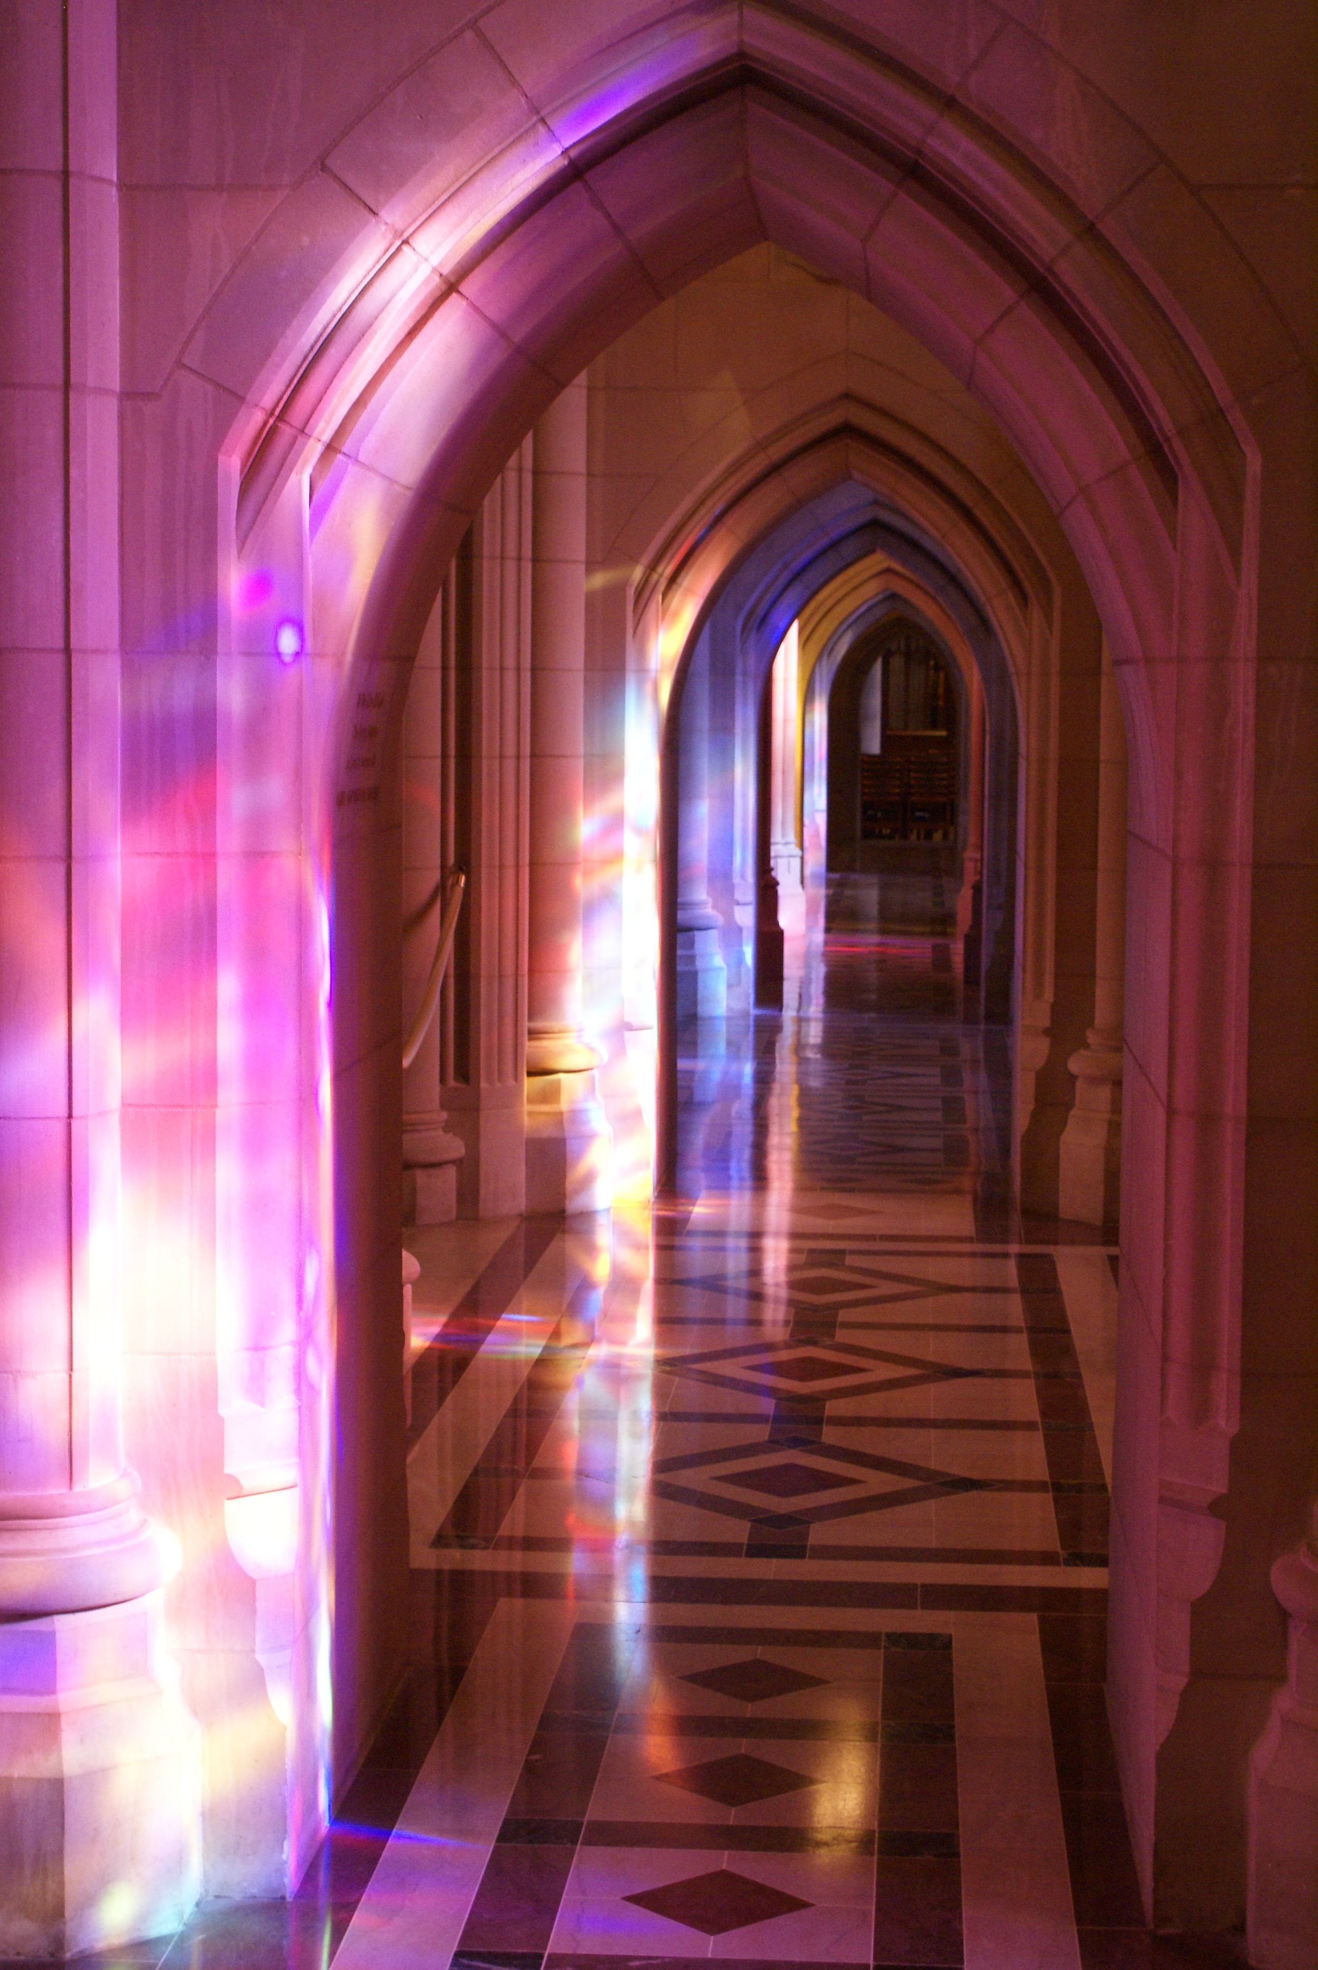

GOLD COIN ENTRY.
For more information please contact Shane on 0413607370.

